**GIL MICHAEL E. REGALADO BS ECE IV EE 272**

**LABORATORY RS FLIP-FLOP**

In electronics, flip-flop or latch is a circuit that has two stable states and can be used to store information. A flip-flop is a bi-stable multivibrator. The circuit can be made to change state by signals applied to one or more control inputs and will have one or two outputs. It is the basic storage element in sequential logic. Flip-flops and latches are a fundamental building block of digital electronics systems used in computers, communications, and many other types of systems.

SCHEMATIC

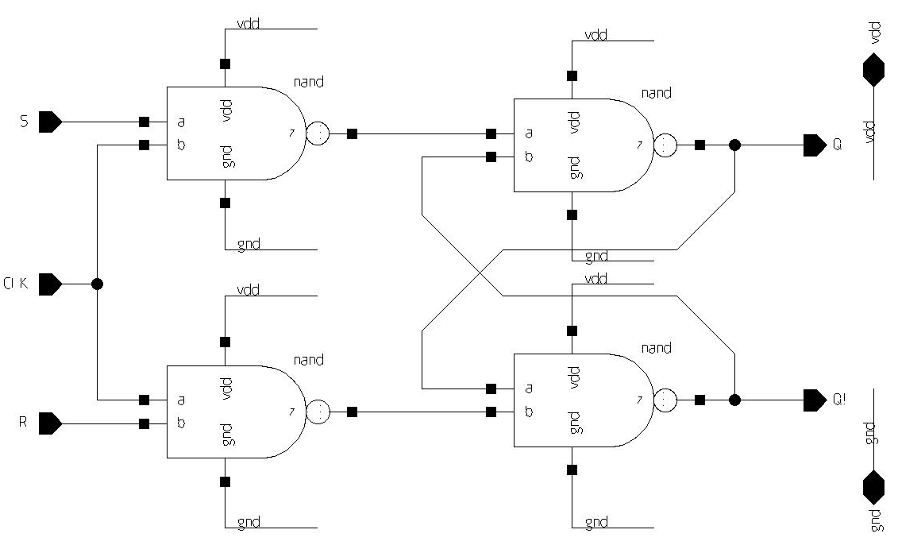

TEST BENCH

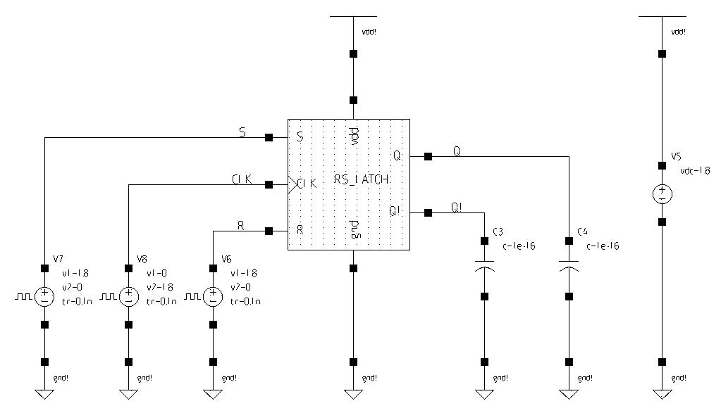

SIMULATION

